Safeguarding Policy

Version: | Review date: | Edited by: | Approved by: | Comments:
1 | January 2023 | C.Harrison | J.Wain | New combined policy
1.2 | June 2025 | A.Baker | A.Baker | Reviewed and updated

Table of contents
1 Introduction 5
1.1 Policy statement 5
1.2 Status 5
2 Definition of terms 6
2.1 Adults with care and support needs (adults) 6
2.2 Advocacy 6
2.3 Child 6
2.4 Child criminal exploitation (children) 6
2.5 Child in need (children) 6
2.6 Child protection (children) 7
2.7 County lines 7
2.8 Discriminatory abuse 7
2.9 Emotional abuse 7
2.10 Female genital mutilation 7
2.11 Financial abuse 7
2.12 Forced marriage 8
2.13 Honour-based violence 8
2.14 Human rights 8
2.15 Institutional abuse 8
2.16 Looked after children (LAC) (children) 8
2.17 Making safeguarding personal (MSP) 9
2.18 Modern slavery 9
2.19 Neglect 9
2.20 Physical abuse 9
2.21 Private fostering (children) 9
2.22 Safeguarding 10
2.23 Self-neglect 10
2.24 Sexual abuse 10
2.25 Sexual exploitation (children) 10
2.26 Significant harm (children) 10
2.27 Young carers (children) 10
3 Legislation and governance 11
3.1 Legislation 11
3.2 Governance 11
4 Policy 12
4.1 Overview 12
4.2 Organisation statement 12
4.3 Principles of safeguarding 12
4.4 Mental capacity 13
4.5 Liberty Protection Standards 14
4.6 Emotional Wellbeing Mental Health Services (EWMHS) 14
4.7 CONTEST and PREVENT 14
5 Adults – indicators of abuse 15
5.1 Physical abuse 15
5.2 Emotional abuse 15
5.3 Sexual abuse 15
5.4 Neglect 16
5.5 Self-neglect 16
5.6 Discriminatory abuse 16
5.7 Institutional abuse 16
5.8 Financial abuse 16
5.9 Modern slavery 17
5.10 Forced marriage (adults or children) 17
5.11 Honour based violence 17
5.12 County lines 18
6 Children – indicators of abuse 18
6.1 Physical abuse 18
6.2 Emotional abuse 18
6.3 Sexual abuse 19
6.4 Neglect 19
6.5 County lines 19
6.6 Unborn child 20
6.7 Female genital mutilation (FGM) 20
7 Raising a concern – action to be taken by staff 21
7.1 General 21
7.2 Adult at risk – action to be taken 21
7.3 Child at risk – action to be taken 22
7.4 Parental responsibility 22
7.5 Risks to the child following parents separating 23
7.6 Movement of at-risk patients 23
7.7 Other matters to be considered 24
7.8 Raising an alert 24
7.9 Record-keeping 25
7.10 Sharing of information 25
7.11 Ongoing monitoring of vulnerable patients 27
7.12 External support for victims 27
8 Training 28
8.1 Training overview 28
8.2 Minimum training requirements 28
8.3 Further training 29
9 Other safeguarding matters 29
9.1 Safer recruitment 29
9.2 Whistleblowing 29
9.3 Allegations against a member of staff 30
9.4 Chaperoning 30
9.5 Professional challenge 30
10 Failure to attend an appointment 31
10.1 Did not attend (DNA) 31
10.2 Was not brought (WNB) 31
10.3 Actions for a WNB 31
10.4 Referring a WNB 33
10.5 Useful numbers 33
11 Safeguarding and responsibilities 33
11.1 Information flow 33
11.2 Regional and national support information 33
11.3 CQC safeguarding responsibilities 34
11.4 Organisations’ safeguarding responsibilities 35
11.5 Organisation safeguarding lead 35
11.6 Partners/directors 36
11.7 Practice manager 36
11.8 GPs 37
11.9 The senior nurse 37
11.10 All staff 37
11.11 Audit 38
12 Domestic abuse 38
12.1 Domestic Abuse Act 2021 38
12.2 Recognising domestic abuse 38
12.3 Understanding the impact of domestic abuse 39
12.4 Multi-agency response to domestic abuse 39
13 Summary 39

Annexes

Annex A - Was not brought (WNB) letter
Annex B - Safeguarding leaflet
Annex C - Safeguarding audit tool

Introduction

Policy statement

The purpose of this document is to set out the requirements for The Organisation to take the appropriate actions for safeguarding children, young people and adults at risk of harm or abuse, in line with extant legislation. This document will be updated as and when changes to legislation occur. Staff should refer to the legislative documents to always ensure relevance.

Additionally, staff should also refer to any local Standard Operating Procedures (SOPs) relating to safeguarding at The Organisation.

This policy should be read in conjunction with the following CQC Mythbusters:

- GP Mythbuster 25: Safeguarding adults at risk
- GP Mythbuster 33: Safeguarding children
- GP Mythbuster 80: Female genital mutilation (FGM)

This document has been purposefully compiled as a joint safeguarding policy for adults and children. Feedback from the CQC, CCG, safeguarding leads and organisations has been varied and some have stated that they require a separate policy whilst others prefer a joint policy.

For ease, throughout the document, in the heading for the section it states whether this refers to a child or an adult and where there is no such indication, this means it is generic and refers to both.

Therefore, this will ensure that it will be easier to segregate as required.


See Chapter 8 for further guidance and links to training.

Status

The organisation aims to design and implement policies and procedures that meet the diverse needs of our service and workforce, ensuring that none are placed at a disadvantage over others, in accordance with the Equality Act 2010. Consideration has been given to the impact this policy might have regarding the individual protected characteristics of those to whom it applies.

This document and any procedures contained within it are non-contractual and may be modified or withdrawn at any time. For the avoidance of doubt, it does not form part of your contract of employment.

This document applies to all employees of the organisation and other individuals performing functions in relation to the organisation such as agency workers, locums and contractors.

Definition of terms

Adults with care and support needs (adults)

The Care Act 2014 defines adults with care and support needs as those aged 18 and over who:
- Have needs for care and support (whether the local authority is meeting any of those needs) and;
- Are experiencing, or at risk of, abuse or neglect; and
- As a result of those care and support needs, are unable to protect themselves from either the risk of or the experience of abuse or neglect.

Advocacy

Advocates help to ensure that a person’s rights are upheld and that their views, wishes and needs are heard, respected and acted on.

Child

A person under the age of eighteen

Child criminal exploitation (children)

Child criminal exploitation (CCE) occurs when an individual or group takes advantage of an imbalance of power to coerce, control, manipulate or deceive a child or young person under the age of 18. The victim may have been criminally exploited even if the activity appears to be consensual.

CCE does not always involve physical contact; it can also occur through the use of technology.

Child in need (children)

Under Section 17 of the Children Act 1989, a child will be considered in need if:
- They are unlikely to achieve or maintain or to have the opportunity to achieve or maintain a reasonable standard of health or development without the provision of services from the Local Authority
- Their health or development is likely to be significantly impaired, or further impaired, without the provision of services from the Local Authority
- They have a disability. Disability includes blindness, deafness or dumbness, mental disorders and permanent illnesses, injuries or congenital deformities

Child protection (children)

Child protection sets out the clear actions needed to keep a child safe and well.

Where a child is at risk of harm, a conference with key agencies will share information, identify any risks to the child and outline the actions required to protect the child.

County lines

County lines is a term used to describe gangs, groups or drug networks that supply drugs from urban to suburban areas across the country, including market and coastal towns, using dedicated mobile phone lines or ‘deal lines’. It involves exploiting children and vulnerable adults to move drugs and money to and from the urban area and to store the drugs in local markets. It involves intimidation, violence and the use of weapons including knives, corrosives and firearms.

Discriminatory abuse

Discriminatory abuse occurs when values, beliefs or culture result in a misuse of power, causing denied opportunities. Motivating factors include age, gender, sexuality, disability, religion, class, culture, language, race or ethnic origin.

Emotional abuse

For a child, emotional abuse is the constant emotional mistreatment, the intention of which is to cause significant adverse effects on the emotional development of the child. Emotional abuse also includes overprotection and the restriction of a child learning or partaking in normal social interaction.

For all, emotional abuse is behaviour that has a detrimental effect on the individual’s emotional wellbeing and may result in distress, e.g., bullying, verbal abuse, intimidation, isolation, over-protection or a restriction or withdrawal of an individual’s human and/or civil rights.

Female genital mutilation
Female genital mutilation (FGM) comprises all procedures that involve partial or total removal of the external female genitalia or other injury to the female genital organs for non-medical reasons.
Further reading can be sought in the Clinical Guidance Document – FGM.

Financial abuse

Financial abuse is the use of an individual’s funds, property, assets, income or other resources without their informed consent or authorisation. This is a crime. Financial abuse includes theft, fraud, exploitation, misuse of benefits or the misappropriation of property, inheritance or financial transactions.

Forced marriage

A forced marriage became illegal in June 2014 under the Anti-social Behaviour Crime and Policing Act 2014 and it is a form of domestic abuse. It is primarily against women, although not exclusively, and most cases involve females aged between 13 and 30.

Forced marriage is a marriage conducted without the consent of one or both parties or where consent is obtained under duress and is markedly different from an arranged marriage in which the individuals retain free will and have the choice to accept the arrangement.

In forced marriage, perpetrators use physical, sexual, psychological or financial abuse to pressurise people to marry against their will.

Rubie’s story can be heard in this YouTube video clip by the University of Derby.

Honour-based violence

This term is used to describe violent or threatening behaviour which is committed to protect or defend perceived cultural beliefs or the honour of the family.

Honour-based violence is not acceptable behaviour and is illegal. Some of those who commit this crime mistakenly believe someone has brought shame on their family or community that compromises their traditional beliefs or culture.

Further advice can be found in this YouTube video clip by the charity, Karma Nirvana.

Human rights

The rights inherent to all human beings, regardless of race, sex, nationality, ethnicity, language, religion or any other status.

Institutional abuse

Institutional abuse refers to a lack of respect in a health or care setting which involves routines that meet the needs of staff as opposed to the needs of the individual at risk and violate the individual’s dignity and human rights.

Looked after children (LAC) (children)

A child placed in the care of their local authority for more than 24 hours. A looked after child may also be referred to as a ‘child in care’. Looked after children may be living with foster parents, living in residential children’s homes or other residential settings e.g., a secure unit.

NICE Guidance 205 guidance in relation to safeguarding recommends that organisations, practitioners and carers work together to deliver high-quality care, stable placements and nurturing relationships for looked after children.

Making safeguarding personal (MSP)

A Local Government Association initiative which aims to develop an outcomes focus to safeguarding work, and a range of responses to support people to improve or resolve their circumstances.

Modern slavery

This includes slavery, human trafficking, servitude and forced labour. Individuals are coerced, deceived and forced into a life of abusive and inhumane treatment.

Further information and guidance can be found in the Modern Slavery and Human Trafficking Guidance document.

Neglect

For a child, neglect is the continued failure to ensure that a child’s physical and psychological needs are met, resulting in significant impairment of the development of the child.

Examples of neglect include failing to provide adequate supervision, failing to respond to emotional needs, a lack of protection (from emotional or physical harm), failing to provide clothing, accommodation and food. Drug and alcohol misuse is a factor in a significant number of children in need and child protection cases.

For all, neglect has two forms; it can be intentional or unintentional and it results in the needs of the individual not being met. Examples of intentional neglect include failure to provide the required level of care, preventing care from being administered, failure to provide access to services such as health and social care, education and other support services. Unintentional neglect may include a failure to provide the at-risk individual with the necessary level of care as the responsible person (e.g., the carer) fails to understand the needs of the individual.

Physical abuse

For adults and children, physical abuse can involve burning or scalding, drowning, suffocating, hitting, shaking, throwing, pushing, pinching, exposure to extreme temperatures (hot and cold), female genital mutilation, inappropriate use of medication, poisoning or other means of causing physical harm

For adults, additionally, it could also involve inappropriate restraint and deprivation of liberty.

Private fostering (children)

A private arrangement (without the involvement of a local authority) to care for a child under 16, or under 18 if disabled, by a person other than the parent or close relative for an expected period of more than 28 days.

Safeguarding

Safeguarding means protecting people’s health, wellbeing and human rights and enabling them to live free from harm, abuse and neglect. It is fundamental to high-quality health and social care.

Self-neglect

Self-neglect includes a lack of self-care, a lack of care of one’s environment and the refusal of services that would reduce the risk of harm. Self-neglect may occur because the individual is unable to care for or manage themselves, they are unwilling to manage themselves, or both.

Sexual abuse

For a child, sexual abuse is the enticement or forcing of a child/young person to participate in sexual activities. This involves penetration or non-penetrative acts, physical contact or non-contact activities such as the encouraging of a child or young person to watch sexually inappropriate content.

For all, sexual abuse includes sexual exploitation, including the involvement of an adult in a sexual activity they have not consented to, the encouragement to watch any form of sexual activity, coercion into any form of sexual activity or the involvement of the adult in such scenarios when they lack the capacity to consent.

Sexual exploitation (children)

Child sexual exploitation (CSE) occurs when an individual takes sexual advantage of a child or young person (anyone under the age of 18) for his or her own benefit.

Power is developed over the child or young person through threats, bribes, violence and humiliation or by telling the child or young person that he or she is loved by the exploiter. This power is then used to induce the child or young person to take part in sexual activity.

Significant harm (children)

Section 31 (3c) (9) of the Children Act 1989 defines ‘harm’ as the ill-treatment or impairment of the child. Whilst ‘significant’ harm is not defined under the Act, this will be decided by the local authorities working with family members to assess the child.

Young carers (children)

A person who regularly provides emotional and/or practical support and assistance for a family member who is disabled, physically or mentally unwell or misuses substances.

Legislation and governance

Legislation

The following legislation supports this document:
- Children Act 1989
- The Human Rights Act 1998
- Children ACT 2004
- Childcare Act 2006
- Children (private arrangements for fostering) regulations 2005
- Carers (Recognition and Services) Act 1995
- The Care Act 2014
- Mental Capacity Act 2005
- Mental Capacity (Amendment) Act 2019
- Serious Crime Act 2015
- Domestic Abuse Act 2021

Governance

The clinical safeguarding lead and deputy are responsible for all aspects of the safeguarding procedures at The Organisation . Furthermore, any changes to this policy will be signed off by the safeguarding leadership team.

Reference will also be made to latest guidance including:

- CQC – Inspector's Handbook – Safeguarding (2018).
- RCGP – Safeguarding
- NICE – guidance and quality standards
- Gov.uk – Working together to safeguard children – Statutory framework

The following table details the safeguarding leads within this organisation.

Lead | Name and role
Adult Safeguarding lead | Dr Emma Palmer
Child Safeguarding leads | Dr Emma Palmer
Adult Deputy safeguarding lead
Child Deputy Safeguarding Lead
PREVENT lead | Dr Emma Palmer
Safeguarding administration lead | Lucy O’Connell

Policy

Overview

The safeguarding of children, young people and adults at risk is paramount for healthcare professionals and all team members working at The Organisation.

It is essential that all staff are fully aware of their responsibilities to detect individuals at risk, provide the necessary support to those affected by safeguarding issues and ensure a high-quality service, including the appropriate sharing of information.

Organisation statement

The Organisation recognises that all children, young people and adults at risk have a right to protection from abuse and neglect and the organisation accepts its responsibility to safeguard the welfare of such persons with whom staff may come into contact.

We will respond quickly and appropriately where information requests are made, abuse is suspected or allegations are made in relation to children, young people or adults at risk. Furthermore, we will give children, young people, their parents and adults at risk the chance to raise concerns over their own care or the care of others and have in place a system for managing, escalating and reviewing concerns.

The organisation will ensure that all staff are given the appropriate safeguarding training, proportionate to their role, and that they attend annual refresher training. New members of staff will receive safeguarding training as part of their induction programme.

Safeguarding responsibilities will be clearly defined in job descriptions and there are nominated leads for safeguarding adults and children.

Principles of safeguarding

It is possible that the GP may be the individual who identifies a child, young person or adult as being at risk.

It is therefore essential that clinicians act appropriately and in a timely manner to reduce the risk of long-term abuse, in accordance with the six principles of safeguarding:

The six principles of safeguarding
1 | Empowerment | People being supported and encouraged to make their own decisions and informed consent
2 | Prevention | It is better to take action before harm occurs
3 | Proportionality | The least intrusive response appropriate to the risk presented
4 | Protection | Support and representation for those in greatest need
5 | Partnership | Local solutions through services working collaboratively
6 | Accountability | Accountability and transparency in safeguarding practice

The organisation supports the safeguarding principles by ensuring that:

- There is a safe recruitment procedure in place, including the effective use of the Disclosure Barring Service (DBS)

- Clear lines of accountability exist within the organisation for safeguarding

- All staff are aware of the safe whistleblowing process

- All staff understand the requirement to work in an open and transparent way

- All patients are treated with dignity and respect regardless of culture, disability, gender, age, language, racial origin, religion or sexuality

- All staff adhere to the guidance in this policy and that given in the referenced texts

- All staff effectively interact with the relevant agencies, sharing information appropriately

- All staff who work with children, young people and adults at risk are responsible for their own actions and behaviour and should avoid conduct that may lead another responsible person to question their motivation and/or intentions

Mental capacity

The Mental Capacity Act (MCA) 2005 offers a framework that details the rights of individuals should their capacity be questioned. The principles of the MCA must be adhered to and are applicable to safeguarding with further guidance here.

Should an individual at risk opt to remain in an abusive situation, it is essential that they choose to do so without duress or undue influence and are fully aware of the risks they may encounter. Should it transpire that the individual has been threatened or coerced, safeguarding interventions must override their decision to ensure that the safety of the individual is protected.

NICE have published guidance to assess mental capacity together with practical resources to enable organisations to put the guidelines into practice. The pathway covers a wide breadth of scenarios for practitioners to utilise including executive decisions in cases such as traumatic brain injury when capacity is more difficult to establish.

Liberty Protection Standards

In addition to the MCA 2005 and the later Mental Capacity (Amendment) Act 2019, the organisation will determine if a person is deemed to have been deprived of their liberty as detailed in the Liberty Protection Standards.

Where it is suspected that the deprivation is unlawful, the organisation will report this to the local authority within 48 hours. Additionally, the local authority has the legal power to sanction and issue a deprivation of liberty order should it be deemed necessary to restrict the freedom of an individual if it is found to be in their best interest.

Further reading can be sought from the Mental Capacity Act Policy.

Emotional Wellbeing Mental Health Services (EWMHS)

Children and vulnerable adults (up to the age of 25 years with Special Educational Needs) will be offered referral to EWMHS if they need support with any of the following wellbeing or mental health difficulties:
- Anxiety
- Depression
- Stress
- Eating disorders
- Suicide
- Attention deficit hyperactivity disorder (ADHD)
- Autism spectrum
- Emotional and behavioural difficulties
Referral will be made via the up to date guidance.

CONTEST and PREVENT

In 2011, the government introduced the PREVENT strategy as part of the counter-terrorism strategy, CONTEST. The purpose of PREVENT is to stop individuals becoming involved in terrorism. This includes violent and non-violent extremism which can create an atmosphere conducive to terrorism.

CHANNEL is a support programme that helps those individuals who are at risk of being drawn into terrorism. Further guidance can be found at the Gov.uk webpage titled Channel and Prevent Multi-Agency Panel (PMAP) guidance.

It is possible that staff will meet and treat people who are at risk of being drawn into terrorism, including supporting violent or non-violent extremism or being susceptible to radicalisation. If a member of staff suspects that an individual is at risk, they should speak to the organisation’s clinical safeguarding lead or, in his/her absence, to the deputy clinical safeguarding lead.

It may be necessary to contact the regional PREVENT coordinator (RPC) for further guidance.

Adults – indicators of abuse
The following are indicators of abuse in adults at risk:

Physical abuse

Possible indicators for physical abuse may include:

- Unexplained injuries or injuries inconsistent with the person’s lifestyle
- Inconsistent history or a changing history
- Bruising, burns, marks, regular injuries
- Unexplained falls
- Changes in behaviour or low self-esteem
- A delay or failure in seeking medical support
- Signs of malnutrition

Emotional abuse

Possible indicators of emotional abuse:

- Low self-esteem
- Uncooperative and/or aggressive behaviour
- Resentment, anger, distress
- Insomnia
- False claims to attract unnecessary treatment (claims may also be from controlling family member)
- Behavioural changes when in the presence of a particular person

Sexual abuse

Possible indicators of sexual abuse include:

- Bruising to thighs, buttocks, upper arms and marks on the neck
- Torn, soiled or bloodied undergarments
- Genital pain, itching or bleeding
- Difficulty in walking or sitting
- Presence of foreign bodies
- Sexually transmitted diseases
- Pregnancy in women who are unable to consent to sexual intercourse
- Fear of help with personal care
- Reluctance to be alone with a particular person

Neglect

Possible indicators of neglect:

- Dirty, unhygienic living space
- Poor personal hygiene
- Pressure sores, ulcers
- Insufficient or inadequate clothing
- Untreated injuries
- Malnutrition
- Failure to engage with social groups
- Failure to bring to booked appointments

Self-neglect

Possible indicators of self-neglect:

- Unkempt appearance
- Unable or unwilling to take medication
- Extremely poor personal hygiene
- Lack of essentials (food and/or clothing)
- Hoarding
- Living in unacceptable conditions
- Malnutrition and dehydration

Discriminatory abuse

Possible indicators of discriminatory abuse:

- Withdrawn appearance
- Expressions of anger, frustration, anxiety or fear
- Poor support that does not meet the needs of the individual

Institutional abuse

Possible indicators of institutional abuse:

- Poor record-keeping and standards of care
- Lack of flexibility, procedures, management and support
- Inadequate staffing levels, recreational and educational activities
- Lack of choice
- Dehydration, hunger, lack of personal clothing and possessions
- Unnecessary exposure during bathing or when using the lavatory
- Lack of confidentiality
- Lack of visitors

Financial abuse

Possible indicators of financial abuse:

- Unexplained withdrawals from accounts
- Lack of available funds
- Missing personal possessions
- Rent arrears and/or eviction notice
- Unnecessary maintenance
- Lack of receipts for financial transactions
- Persons showing an unusual interest in an individual’s assets
- Lack of food etc.

Modern slavery

Possible indicators of modern slavery:

- Isolation
- Malnutrition
- Unkempt appearance
- Always wearing the same clothes
- Lack of personal possessions
- Unable to prove identity, i.e., lack of documentation
- Signs of physical or emotional abuse

Forced marriage (adults or children)

This crime remains largely under-reported as many victims are too frightened to come forward for fear of the repercussions on their families. There are many indicators of forced marriage and these can be sought here.

A dedicated Governmental Forced Marriage Unit (FMU) is available and can be emailed at fmu@fcdo.gov.uk.

The unit can be contacted via:

- 020 7008 0151 (Monday to Friday between 0900 – 1700 only)
- 020 7008 5000 (out of hours)
- +44 (0)20 7008 0151 (from overseas)

For further information on forced marriage see here including how to raise Form FL401A: Application for a Forced Marriage Protection Order.

Honour based violence

Possible indicators of honour-based violence may include:

- Lengthy or repeated absence from school, a decline in academic performance
- Depression, anxiety, self-harm, substance misuse, suicidal thoughts
- Poor attendance at work or a drop in performance
- Non-attendance at events outside of the normal working environment
- Restrictions on friends
- Disapproval of adopting a different style (or ‘western’) type of clothing and/or the wearing of make-up

Honour-based violence encompasses a range of offences including murder, rape, assault, abduction and domestic abuse. Both men and women are at risk.

County lines

Possible indicators of county lines involvement include:

- Becoming more secretive, aggressive or violent
- Meeting with unfamiliar people
- Persistently going missing from their home or local area
- Leaving home without an explanation or staying out unusually late
- Loss of interest in work and a decline in performance
- Suspicion of physical assault or unexplained injuries
- Using language relating to drug dealing, violence, or gangs
- Carrying a weapon
- Association with a gang
- Becoming isolated from peers and social networks
- Having a friendship or relationship with someone who appears controlling
- Using drugs, especially if their drug use has increased
- Unexplained acquisition of money, drugs or mobile phones

Children – indicators of abuse
The following are common presentations in which abuse may be suspected in a child or young person:

Physical abuse

Possible indicators of physical abuse:
- Bruises, burns, scalds, bite marks, fractures and other injuries
- Admission by the child or young person
- Unwillingness to change into PE kit at school
- Physical signs and symptoms that could be attributed to any category of abuse and/or are inconsistent with the history given
- An inconsistent history or one that changes over a period of time
- A delay in seeking medical support
- Extreme or worrying behaviour
- Self-harm
- An accumulation of minor incidents, including repeated attendance at A&E
- Repeated attendance of a baby under 12 months of age
- Bruising or injury to a child under 24 months of age

Emotional abuse

Possible indicators of emotional abuse:

- Overly affectionate towards strangers
- Anxious or showing a lack of confidence or appearing clingy
- Inappropriate language or subjects for their age
- Extreme outbursts or very strong emotions
- Showing isolation from parents or carers
- Lack of social skills or have very few friends
- Bed-wetting
- Poor attendance at school
- Insomnia

Sexual abuse

Possible indicators of sexual abuse:

- Avoidance of spending time alone with certain individuals
- Fear or unwillingness to socialise with certain persons
- Use of sexual language or knowing information that would not usually be expected
- Vaginal or anal soreness and/or discharge
- Sexually transmitted infections
- Young girls or girls with learning difficulties or a disability requesting contraception, especially emergency contraception
- Girls under 16 presenting with pregnancy and/or sexually transmitted infections, especially those with learning difficulties, long-term illness or complex needs or disability
- Promiscuity
- Having unexplained physical injuries
- Association with groups of older people or antisocial groups

Neglect

Possible indicators of neglect:
- Poor appearance and hygiene
- Inadequate clothing
- Hunger or lack of money for school meals
- Untreated nappy rash in infants
- Untreated injuries, conditions and dental cases
- Recurring illness or infection
- Tiredness
- Evidence of skin sores, rashes, flea bites, scabies or ringworm
- Left alone at home for prolonged periods
- Living in unsuitable environments, e.g., no heating or hot water
- Caring for others in the home, e.g., siblings
- Failure to bring to appointments (WNB)

County lines

Possible indicators of county lines involvement include:

- Persistently going missing from school or home and/or being found out of area
- Unexplained acquisition of money, clothes or mobile phones
- Excessive receipt of texts/phone calls
- Relationships with controlling/older individuals or groups
- Leaving home/care without explanation
- Suspicion of physical assault/unexplained injuries
- Parental concerns
- Carrying weapons
- Significant decline in school results/performance
- Gang association or isolation from peers or social networks
- Self-harm or significant changes in emotional wellbeing

Unborn child

Pregnancy can create circumstances and influences for both parents which need to be understood by all professionals who come into contact with these families.

These include where:

- Previous children in the family have been removed because they have suffered harm
- Concerns exist regarding the mother's ability to protect
- There are concerns regarding domestic violence and abuse
- A parent or other adult in the household, or regular visitor, has been identified as posing a risk to children
- A child in the household is the subject of a Child Protection Plan
- A sibling has previously been removed from the household either temporarily or by court order
- Either parent is a Looked After Child or are known to children’s social care
- Any other concerns exist that the baby may be at risk of significant harm including a parent previously suspected of fabricating or inducing illness in a child or harming a child
- A child aged under 16 and found to be pregnant
- Either or both parents have mental health problems
- Either or both parents have a learning disability
- Either or both parents are under 18 years
- Either or both parents abuse substances, alcohol or drugs
- If the pregnancy is denied or concealed

Greater Manchester Safeguarding Board has developed a toolkit for assessing the safety of the unborn child and this can be found within their procedures manual.

Female genital mutilation (FGM)

FGM has been illegal in the UK since 1985. The Serious Crime Act 2015 strengthened legislation by adding extra requirements for healthcare professionals to report FGM.

The Act details that:

- It grants lifelong anonymity to alleged FGM victims

- It is an offence for parents to fail to protect their child from FGM

- FGM Protection Orders can be introduced to prevent potential victims from travelling abroad

- It is a mandatory reporting duty for nurses, midwives, doctors, social workers and teachers to report to the police whenever they observe physical signs of FGM on a person under the age of 18 or where a girl tells them it has been carried out on her

- It is an offence for FGM to be committed abroad against UK residents.

In addition to the requirements of the Serious Crime Act, it is now mandatory for all GP practices and Acute and Mental Health Trusts to submit data to NHS Digital. Under 18s who may be at risk of FGM should be referred using standard existing safeguarding procedures, usually to children’s services.

The following SNOMED CT codes should be used for FGM:

Heading | Code
Female genital cutting | 429744008
Discussion about female genital mutilation | 713255007
Family history of female genital mutilation | 902961000000107
Discussion about female genital mutilation with carer | 932301000000101
Further detailed information can be sought in the Clinical Guidance Document – FGM and GP Mythbuster 80: Female genital mutilation (FGM).

Raising a concern – action to be taken by staff

General

Should any member of staff have cause for concern, or where a person has disclosed abuse, they are to report these to the following and in this order:

- Dr Emma Palmer (safeguarding lead)

- In his/her absence, Practice Manager (deputy safeguarding lead) should be appraised

- In the absence of one or both leads, and where safeguarding leads are uncertain as to the action required, the senior clinician present must raise the matter with the local safeguarding team. In emergency cases, a decision will be made about contacting the police or social services

- In all instances of safeguarding concerns, Lucy O’Connell, Medical Reports and Patient Data Coordinator will be updated to ensure that they can effectively respond to any external interested parties

Adult at risk – action to be taken

When it is suspected that an adult at risk is suffering from abuse, staff are to:

- Remain focused
- Act in a non-judgemental manner
- Offer support, empathy and remain engaged with the individual
- Reassure the individual throughout the consultation
- Ensure that all information is recorded accurately
- Secure any evidence where possible
- Ensure that they do not give the adult at risk any promises or press them for further information

Child at risk – action to be taken

The Children Act 2004, as an expansion of the earlier 1989 Children Act, reinforces that all people and organisations working with children have a duty to help safeguard children.

When it is suspected that a child or young person is suffering from abuse, staff should:

- Remain focused, take time, slow down
- Reassure the child, explaining to them that they have done the right thing and they are not to blame
- Offer support, empathy and remain engaged with the child/young person
- Explain what needs to be done next
- Ensure that all information is recorded accurately, paying particular attention to dates and times of events
- Do not ask leading questions or promise confidentiality

Further guidance and resources for recognising and responding to abuse in children can be found here.

Parental responsibility

It should be noted that each parent has parental responsibility and, as such, anyone with parental responsibility for a child has a right to seek access to that child's medical records. Parents do not lose parental responsibility if they divorce, however, parental access can be restricted by the court.

Parental responsibility is defined in the Children Act 1989 as “all the rights, duties, powers, responsibilities and authority which by law a parent of a child has in relation to Childcare Act 2006” and is as follows:

- Birth mothers automatically have parental responsibility, as do married fathers. However, in both cases, this can be removed by the court

- When the father is not married to the child's mother, his parental responsibility will depend on when the child was born and those who are named upon on the birth certificate

These named fathers automatically have parental responsibility if the child was born on or after:

  - 1 December 2003 in England and Wales
  - 4 May 2006 in Scotland
  - 15 April 2002 in Northern Ireland

- Unmarried fathers who are not named on the birth certificate do not have automatic parental responsibility. However, they can acquire parental responsibility if they obtain a Parental Responsibility Agreement from the child's mother or a Parental Responsibility Order from the court

- Step parents and civil partners can acquire parental responsibility in the same way as unmarried fathers

- If a child is adopted, the birth parents will lose parental responsibility for their child and, with any child in care, the representatives of the local authority will have parental responsibility for that child

The MDU provides further guidance on both parental responsibility and disputes between parents here. Further details on accessing medical records can be found within the Access to Medical Records Policy.

Risks to the child following parents separating

Occasionally, there may be a request from a single parent suggesting that the other parent must not be allowed to access the child’s medical records and/or must not be involved in the medical care of that child(ren)

Should this organisation receive any such requests from estranged parents, then the advice from MDU titled Children whose parents are separated offers sound guidance. This can be further endorsed by contacting our Organisation’s group indemnity provider, to obtain its thoughts on this matter.

In all situations, this organisation will do what is in the best interest of the child and this may involve discussing any concerns with the safeguarding lead should any staff member believe that the parents do not have best interests of the child(ren) in mind.

Movement of at-risk patients

At The Organisation, our Safeguarding Lead will be responsible for ensuring that a register of all at-risk children, young people and adults is maintained, allowing close oversight of this vulnerable group should there be any request to leave the practice.

Should any patient who has a safeguarding flag request to change practices, there is a risk that, as notes may take time to be transferred, there can be a delay in summarising. Furthermore, it has been known for families to deliberately move practices frequently and consult different healthcare providers to avoid detection.

To minimise any risk, it is imperative that safeguarding concerns are communicated promptly.

At this organisation, the following process overleaf it to be taken:

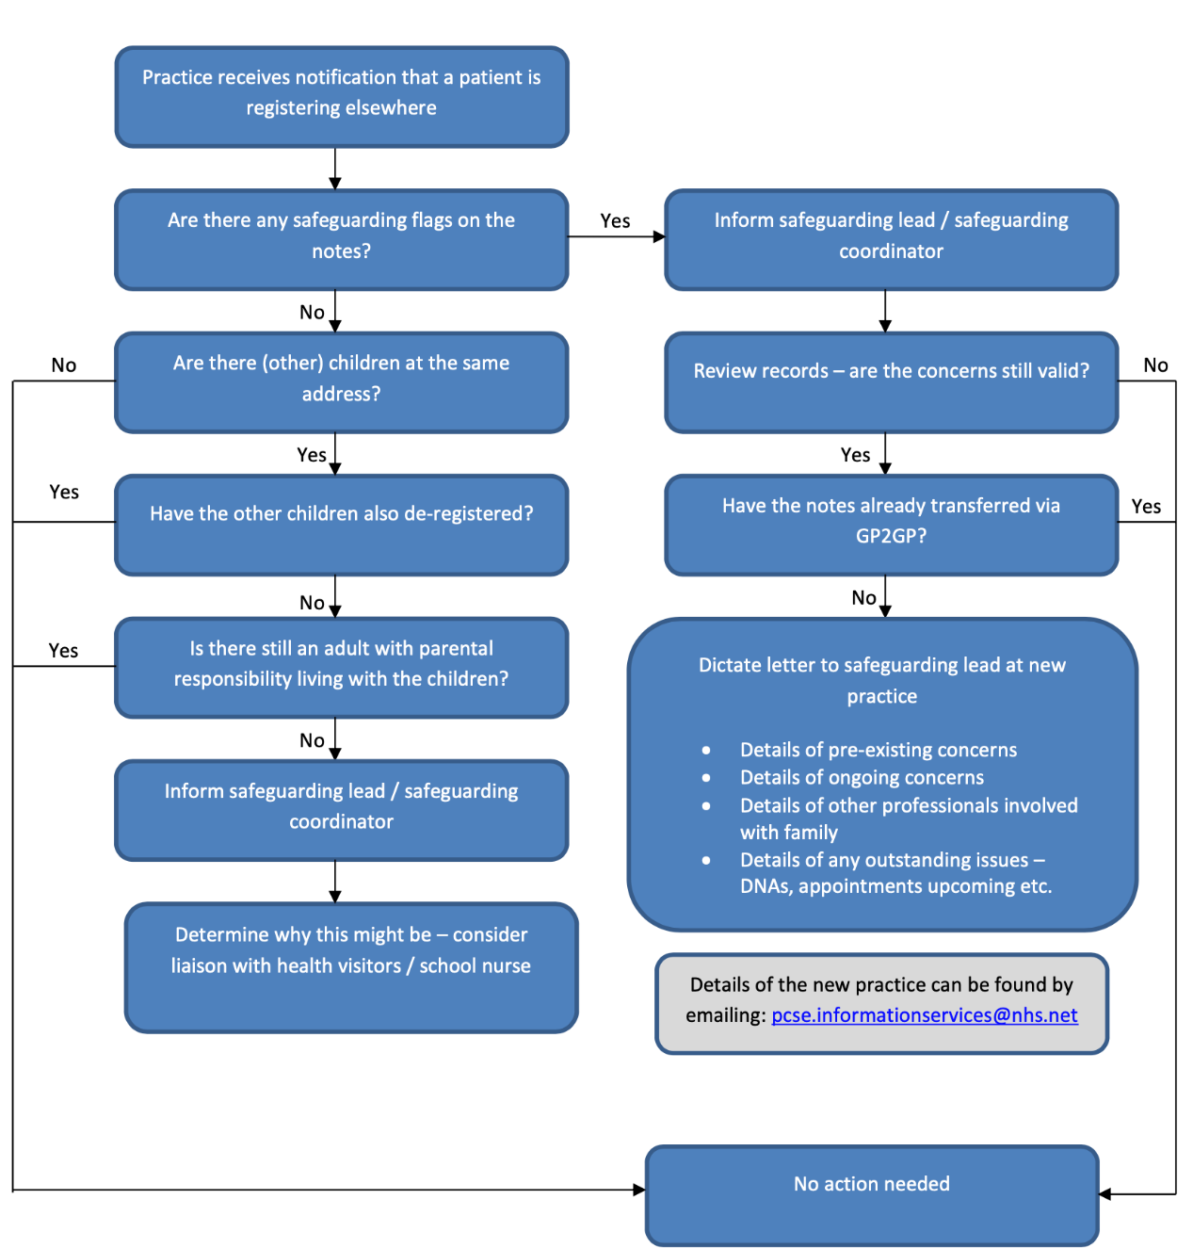

Source: Brighton and Hove CCG - Documenting Safeguarding Concerns (Jan 2020)

Further information can be sought in the Removal of Patients Policy.

Other matters to be considered

Staff must ensure that they stay calm and liaise with the clinical safeguarding lead or nominated deputy to make certain the child, young person or adult at risk is offered the most appropriate level of care. Concerns must be discussed immediately and an action plan devised.

Staff must understand that there are circumstances where a safeguarding alert may be made without consent, e.g., circumstances involving other at-risk groups or where a crime may have been committed. Disclosing this information is referred to as a public interest disclosure to share information.

Raising an alert

When it is necessary to raise an alert, a risk assessment should be undertaken to prevent further risk of immediate harm to the child, young person or adult at risk. The initial assessment should consider:

- Whether the individual is still at risk if they return to the place where the abuse is alleged or suspected to have taken place

- The extent of harm that is likely to occur if the child, young person or adult at risk encounters the person who is alleged to have caused harm

- Whether the alleged person still has access to the child, young person or adult at risk

Once raised, the alert will be managed according to Devon Safeguarding Board to ensure the needs of the individual are met and that the risk of further harm is significantly reduced.

The process will detail the actions to be taken to safeguard the individual at risk, ensuring that those involved are aware of the options available and how they can support the individual throughout the process.

Record-keeping

It is essential that all concerns, discussions and decisions are recorded in the individual’s healthcare record and that the appropriate SNOMED codes for abuse are used.

Any documentation relating to safeguarding should be factual, contemporaneous and should be immediately obvious on a patient’s record to any health professional involved in the patient’s direct care. There should be no more than 48 hours delay in entering safeguarding information to records.

All correspondence relating to any safeguarding matters for a child, young person or adult at risk is to be scanned into the individual’s electronic healthcare record.
Staff are to ensure that, prior to sharing information, any sensitive third-party information is redacted if necessary and the entry marked as “safeguarding relevant” to ensure information is restricted to a “need-to-know” basis.

Child protection reports are also to be scanned into the healthcare record and the appropriate coding used. In such circumstances, the SNOMED code used to illustrate that the child is on a child protection plan should be entered into the notes of all individuals living at the same address.

The administration safeguarding lead will be able to advise staff accordingly if they have any queries or concerns.

Sharing of information

The sharing of information is essential to establish early intervention and the protection of children, young people and adults at risk. Clinicians must understand the need to share information, when it appropriate to share and how they share the information.

Where possible, consent to share should be obtained. However, the safety of the individual is paramount and, where concern exists or individuals are deemed to be at risk from significant harm, then this is to be considered as the determining factor and information should be shared. Where doubt exists, the organisation’s safeguarding lead or nominated deputy should be approached for advice.

There are eight principles to sharing information. With these principles in mind, staff are advised to follow these:

- The Data Protection Act 2018, Chapter 2, the UK General Data Protection Regulation (UK GDPR) and human rights law are not barriers to justified information sharing but provide a framework to ensure that personal information about living individuals is shared appropriately.

- Be open and honest with the individual (and/or their family where appropriate) from the outset about why, what, how and with whom information will, or could be, shared and seek their agreement, unless it is unsafe or inappropriate to do so.

- Seek advice from other practitioners or the information governance lead if there is any doubt about sharing the information concerned, without disclosing the identity of the individual where possible.

- Whenever possible, share information with consent and, if possible, respect the wishes of those who do not consent to share confidential information. Under the Data Protection Act 2018, you may share information without consent if, in your judgement, there is a lawful basis to do so, such as where safety may be at risk. You will need to base your judgement on the facts of the case. When you are sharing or requesting personal information from someone, be certain of the basis upon which you are doing so. Where you do not have consent, be mindful that an individual might not expect information to be shared.

- Consider safety and wellbeing: base your information-sharing decisions on considerations of the safety and wellbeing of the individual and others who may be affected by their actions.

- Necessary, proportionate, relevant, adequate, accurate, timely and secure: ensure that the information you share is necessary for the purpose for which you are sharing it, is shared only with those individuals who need to have it, is accurate and up to date, is shared in a timely fashion and is shared securely (see principles).

- Keep a record of your decision and the reasons for it – whether it is to share information or not. If you decide to share, then record what you have shared, with whom and for what purpose.

Further information in relation to sharing information can be sought from the following:

- UK General Data Protection Regulation (UK GDPR) Policy
- Consent Policy

Ongoing monitoring of vulnerable patients

At The Organisation, our Safeguarding Lead will be responsible for ensuring that a register of all at-risk children, young people and adults is maintained, allowing close oversight of this vulnerable group. The following regular checks will be carried out:

- The register will be cross-referenced with family members and significant others and relationships recorded and highlighted, where indicated

- The register will be checked monthly to ensure the status of all vulnerable patients is up to date and those responsible for direct care will be notified of any changes e.g., child no longer in need or child now subject to a plan. The correct SNOMED codes will be entered and entries marked as safeguarding relevant

- The register will be checked for occasions where a vulnerable patient has missed an appointment or has not attended secondary care following a referral. See Chapter 11 for full guidance on how this is managed

- The register will be checked for movement of vulnerable patients, both into and out of the organisation

- Newly registered vulnerable patients will be flagged to the registered clinician and records will be summarised as a priority to ensure accuracy. If not already offered, the patient/carer/guardian will be offered a face-to-face new patient check appointment with their GP

- Where patients have moved outside of the practice, records will be checked against the national spine to confirm registration elsewhere and paper records will be returned via PCSE as a priority. Where there are concerns that there may be a gap in registration, Dr Emma Palmer (safeguarding lead) will be advised and will consider if further action is required. See Section 8.6 for further details

External support for victims

There are several organisations that provide specific support. Some of the main national charities include:

- Action for Children | - NSPCC
- Citizens Advice | - Rape Crisis
- Crimestoppers | - Refuge
- Justice and Care | - The Salvation Army
- Karma Nirvana | - The Survivors Trust
- Mind | - Women’s Aid

Training

Training overview

This organisation is committed to having arrangements in place to ensure that all staff are trained effectively and to the level required commensurate with their role.

This is in conjunction with the guidance given by the CQC in the following:

- GP Mythbuster 25: Safeguarding adults at risk
- GP Mythbuster 33: Safeguarding children
- GP Mythbuster 80: Female genital mutilation (FGM)

The organisation will ensure that staff are specifically trained according to intercollegiate guidance as follows (links to training can be found at Section 9.3).

Level of training | Staff requirements
1 | Core training  All staff including non-clinical managers and staff working in healthcare services e.g., general administrative and reception staff and volunteers
2 | Minimum level required for non-clinical and clinical staff who, within their role, have contact with children and young people, parents/carers or adults who may pose a risk to children e.g., safeguarding administrators, reception team leads and practice managers
3 | All clinical staff working with children, young people, their parents or carers and any adult who could pose a risk to children who could potentially contribute to the assessing of, planning, intervening in and evaluating the needs of a child or young person and parenting capacity  Note: This includes practice nurses
4 | Named professionals for safeguarding, working with commissioners
5 | Designated professionals, working with the government.

Minimum training requirements

As well as the mandatory training above, additional minimum training times have been provided by RCGP and can be found in the document titled RCGP supplementary guide to safeguarding training requirements for all primary care staff.

This details all levels and all practice staff.

Further training

Safeguarding Children (Levels 1-3) and Adults (1 & 2) training and Domestic violence awareness training are all available from the HUB.

Further reading from intercollegiate guidance includes:

- Adult Safeguarding: Roles and Competencies for Health Care Staff
- Safeguarding Children and Young People: Roles and Competencies for Healthcare Staff

Further NHS training is available and includes:

- Domestic violence
- Child sexual abuse
- Child abuse
- Child protection
- Adult safeguarding

Other safeguarding matters

Safer recruitment

The Organisation will ensure that the appropriate pre-employment checks are carried out prior to any individual commencing work at the organisation. This organisation will mirror the six NHS Employment Check Standards which are:

- Identity Checks
- Employment history and reference checks
- Work health assessments
- Professional registration and qualification checks
- Right to work checks
- Criminal record checks

All checks will be conducted by our Operations Team before staff are recruited into positions at The Organisation. Applicants will be required to undergo either an enhanced or standard DBS check depending on the position applied for.

It is acknowledged that the management team at The Organisation has a legal duty to refer information to the DBS if any employee has harmed, or is deemed to be a risk of harm, to children, young people or adults at risk.

Additional information is contained in the DBS Policy and Recruitment Policy and Procedure.

Whistleblowing

All staff can raise any concerns they have about the conduct of others within the organisation or how the organisation is run in confidence.

Refer to the Whistleblowing Policy and Procedure.

Allegations against a member of staff

All alleged allegations will be investigated thoroughly. The organisation safeguarding lead is to be informed and he/she will consult with the local authority’s safeguarding team (child or adult) and, if necessary, the local police.

The safeguarding lead will advise the individual concerned that an allegation has been made against them but will not disclose any information at this stage.

Such is the seriousness of any alleged allegation, the individual concerned must be managed appropriately in accordance with the organisation’s HR procedures. Allegations do not necessarily merit immediate suspension. This will depend on the person’s role within the organisation and the nature of the allegation.

Allegations are distressing for all concerned, the individual, the organisation’s staff and the alleged person. It is imperative that appropriate advice is sought from the outset. The local authority’s designated officer (LADO) for managing allegations will be able to provide guidance to ensure that the correct process is followed.
Advice may also be sought from the individual’s medical defence union.

Chaperoning

It may be appropriate to offer a chaperone for a variety of reasons. Clinicians should consider the use of chaperones for some consultations and not solely for the purpose of intimate examinations or procedures.

A chaperone can be defined as “an independent person, appropriately trained, whose role is to independently observe the examination/procedure undertaken by the doctor/health professional to assist the appropriate doctor-patient relationship”.

Further guidance can be found in the Chaperone Policy.

Professional challenge

Professional challenge is an encouraging action taken in the best interests of the child, young person or adult at risk. It enables the challenging of decisions or actions by a member of staff if they consider the stated decisions or actions not to be effective enough for those deemed to be at risk.

Should a member of staff disagree with any element of care offered to an at-risk individual, they are encouraged to discuss their concerns with the organisation’s safeguarding lead, their nominated deputy or the local authority safeguarding lead who will provide independent guidance. It is envisaged that most professional challenges will be resolved informally and at a local level.

Failure to attend an appointment

Did not attend (DNA)

Whilst it is acknowledged that there are many reasons for a child, young person or adult at risk to miss an appointment, there may be occasions when failure to attend appointments is a cause for concern.

Appropriate actions can be pivotal in safeguarding the child, young person or adult at risk and, where appropriate, can trigger early interventions to reduce risk.

In known cases where safeguarding is a concern, if a child, young person or adult at risk fails to attend an appointment, it is the responsibility of the patient services team at The Organisation to contact the relatives or carer of the patient to establish the reasons why the patient failed to attend their appointment. The child, young person or adult at risk is then to be offered another appointment based on clinical need.

To ensure those at risk are offered the most appropriate level of support, the member of staff with whom the patient failed to attend is to ensure that the organisation’s clinical safeguarding lead is informed and that any advice given is acted upon accordingly as detailed at Section 8.7 of this policy.

Record keeping of DNAs is important and the appropriate use of the relevant SNOMED code is required to track any trends. Staff must ensure that they understand their individual responsibilities which are given below in Section 12.

Was not brought (WNB)

Repeatedly failing to attend appointments for some children, young person or adult at risk may be an indicator that there is an increased safeguarding risk. At The Organisation, failure to attend in relation to a child or young person will be referred to as “Was not brought” or WNB. This statement clearly reflects the point that children and young people rely on their parents, carers or guardians to bring them for appointments.

Whilst it is acknowledged that many missed appointments are genuine oversights, instances of repeated cancellations, rescheduling of appointments or WNBs all merit cause for concern.

Actions for a WNB

The following diagrams explain the steps to be taken should a child or young person not attend appointments at this organisation

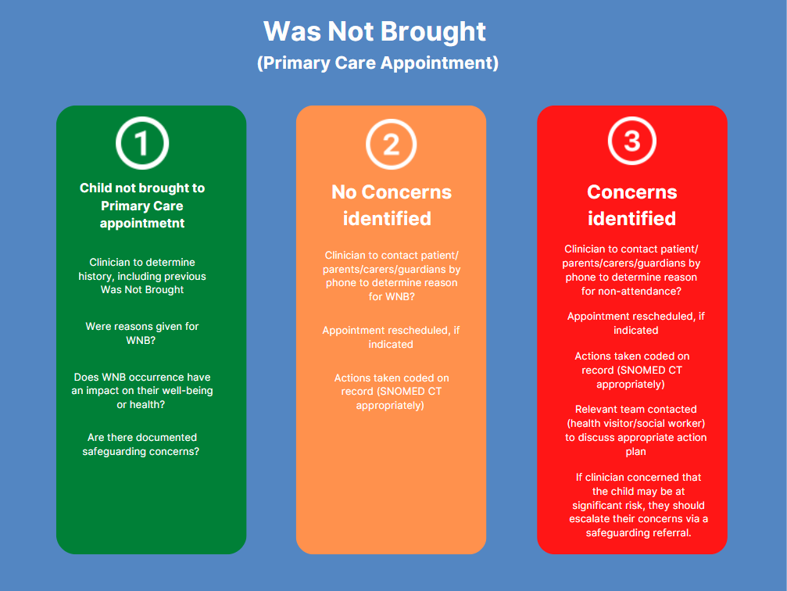

This second diagram below applies if a child or young person does not attend appointments following a referral, i.e., hospital appointment.

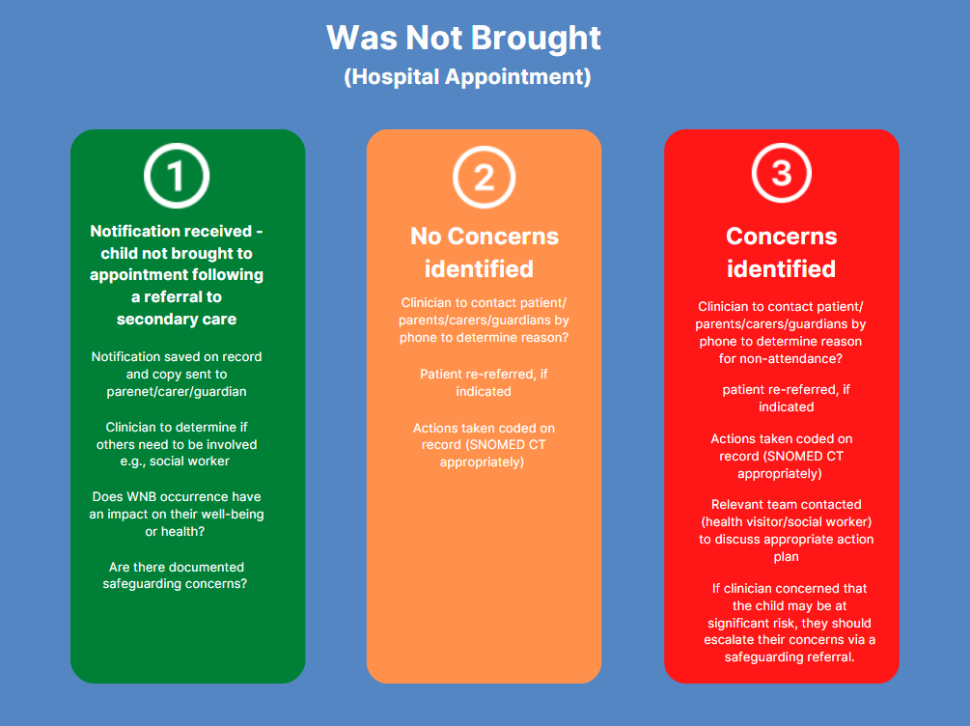

Referring a WNB

If a clinician has significant concerns, they are to initiate a child protection referral using the contact numbers detailed below. Any word-of-mouth referral is to be followed up in writing within 1 working day by the referring clinician. Where the clinician believes that harm is imminent, they should call the police immediately.

All staff are to retain accurate records at all times, ensuring that all actions are annotated, outlining any actions taken. Whilst there is no definitive SNOMED code for WNB, several others are available under ‘Did Not Attend’ for children (see link at 11.1).

A “Was Not Brought” letter template that is to be forwarded to the parent or guardian following a WNB can be found at Annex A.

Useful numbers

- Children’s Social Care Contact Centre: Torbay – 01803 208100, Devon – 0345 155 1071
- Emergency Duty Team: Torbay – 0300 4564 876, Devon 0845 6000 388
- Local Safeguarding Children Board: Plymouth & Torbay Website, Devon Website

Safeguarding and responsibilities

Information flow

Information relating to key responsibilities will be shared with the wider team via information books on desks, meetings, newsletters and on the shared drive.

Regional and national support information

Contact information
Named GP for safeguarding children | Dr Emma Palmer
Named GP for safeguarding adults | Dr Emma Palmer
Primary Care Safeguarding Team | D-ICB.safeguardprimecare@nhs.net
Safeguarding Children Team | D-ICB.sguardchild@nhs.net
Looked After Children Team | D-ICB.lookedafterchildren@nhs.net
Safeguarding Adults Team | D-ICB.safeadults@nhs.net
Police Child Abuse Investigation Unit | Sharon Mahy – 01364 625963
NSPCC Childline | 0800 1111
Child Local Safeguarding board | Torbay Multi-Agency Safeguarding Hub  01803 208 100  torbay.safeguardinghub@torbay.gov.uk  Out of hours – 0300 456 4876  Devon Children and Families Partnership (DCFP)  0345 155 1071  mashsecure@devon.gov.uk  Out of hours – 0845 6000 388
Adult Local safeguarding board | Torbay  01803 219 700  Safeguarding.alertstct@nhs.net  Out of hours – 0300 456 4876  Torbay Online Reporting  Devon  0345 1551 007  Csc.caredirect@devon.gov.uk  Out of hours – 0345 155 1071  Devon Online Reporting

CQC safeguarding responsibilities

Information within this section has been adapted from the CQC Inspector Handbook on Safeguarding.

The primary safeguarding responsibilities of the CQC are:

- Ensuring providers have the right systems and processes in place to make sure children and adults are protected from abuse and neglect

- Working with other inspectorates to review how health, education, police and
probation services work in partnership to help and protect children, young
people and adults from harm
- Holding providers to account and securing improvements by taking enforcement action

- Using intelligent monitoring where information is collected and analysed about services and responding to identified risks to help keep children and adults safe

- Working with local partners to share information about safeguarding

The CQC is not responsible for conducting safeguarding investigations or enquiries as this is for the relevant local authority or the police.

Likewise, the CQC does not routinely attend Safeguarding Adult Boards (SABs) or Local Safeguarding Children’s Boards (LSCBs), although they may share information and intelligence to help all safeguarding teams to conduct enquiries.

Organisations’ safeguarding responsibilities

During any inspection, the CQC will expect that all the following fundamental processes are adopted and embedded at The Organisation. Failure to meet any of these points may cause unacceptable harm to our patient population.

- Demonstrate the understanding of the definition of both adults and children at risk and the types of abuse they may be subject to

- Sufficient priority is given to safeguarding and staff take a proactive approach to prevention and early identification

- Take steps to protect vulnerable adults, children and young people where there are known risks and to respond appropriately to any signs or allegations of abuse

- Work effectively with other organisations to implement protection plans and comply with accepted national guidance on staff competencies in line with their role

- There is an active and appropriate engagement in local safeguarding procedures and effective work with other relevant organisations and incidences of abuse or potential abuse are referred to local authority safeguarding teams

- Systems, processes, policies, procedures and training to help to ensure children and adults who use services are safeguarded from the risk of or actual abuse and neglect are put in place and operate effectively

- Any shortcomings found in safeguarding practice in their service to help reduce the risks to people who use the service and to learn and apply learning from any safeguarding incident are remedied

- The CQC is notified of safeguarding incidents in accordance with regulations by completion of a statutory notification at the time the abuse is identified Further information regarding the requirements where informing CQC is needed, coupled with examples can be sought within both adult and child CQC GP Mythbusters

- For FGM considerations, organisations are to consider how staff are supported to fulfil the legislative requirements and how to refer women and girls for the subsequent physical and psychological consequences

Further information can be found within the referenced CQC handbook and regulatory expectations can be sought from the linked Mythbusters.

Organisation safeguarding lead

The organisation safeguarding lead is responsible for:

- Ensuring that they are fully au fait with the internal, regional and national policies and procedures that underpin safeguarding

- Acting as the focal point within the organisation for staff who may have concerns, addressing the concerns and acting as necessary

- Reviewing any information regarding safeguarding concerns, investigating matters further if necessary and taking the appropriate action

- Acting as the liaison between the organisation and the local safeguarding teams, facilitating the sharing of information, attending multi-agency meetings and supporting any local safeguarding investigations where requested

- Processing and sharing information within the organisation in the most effective manner

- Continually reviewing the organisation’s safeguarding processes and policy, making recommendations for change as necessary

- In conjunction with the deputy safeguarding lead and organisation manager, ensuring compliance with policy and process by means of audit

- Encouraging training for all staff groups

- Ensuring staff are supported appropriately when dealing with any safeguarding matter

Note:

The deputy organisation safeguarding lead will assume the above responsibilities in the absence of the organisation safeguarding lead.

Partners

The partners are responsible for:

- Ensuring safeguarding children, young people and adults at risk is central to clinical governance

- Contractual compliance with clinical governance arrangements for effective safeguarding policies and procedures

- Ensuring that all staff are trained and know how to react to concerns raised and recognise potential indicators for abuse

Practice manager

The practice manager is responsible for:

- Ensuring that safeguarding responsibilities are clearly defined in the job descriptions of all staff

- Adhering to the pre-employment requirements and ensuring that an effective recruitment process is in place

- Reaffirming the significance of safeguarding to all staff within the organisation

- Amending and keeping the safeguarding children, young people and adults’ leaflet (see Annex B) current and also freely available to all staff and patients

GPs

The GPs are to:

- Take prompt action if they think that patient safety, dignity or comfort is being compromised

- Protect and promote the health of patients and the public

In addition, GPs should be afforded the necessary time to effectively contribute to safeguarding meetings, case conferences and external meetings in support of their patients.

The senior nurse

The organisation’s senior nurse is responsible for ensuring compliance with the NMC Code of Conduct and:

- Acting as an advocate for the vulnerable, challenging poor practice and discriminatory attitudes and behaviour relating to their care

- Sharing necessary information with other healthcare professionals and agencies only when the interests of patient safety and public protection override the need for confidentiality

- Sharing information to identify and reduce risk

- Raising concerns immediately if they believe a person is vulnerable or at risk and needs extra support and protection

All staff

All staff have a responsibility to:

- Know how to act should they recognise potential indicators of abuse or neglect

- Understand the organisation’s and local safeguarding policies and procedures

- Partake in meetings and case conferences when requested regarding safeguarding matters

- Attend and/or complete regular training commensurate with their role in accordance with their individual terms of reference and practice policy

Audit

To ensure compliance with this policy and the processes contained within it, the organisation’s safeguarding lead, deputy safeguarding lead and the practice manager will ensure that regular audits are undertaken.

A toolkit of audit can be found at Annex C.

Domestic abuse

Domestic Abuse Act 2021

The prevention of domestic abuse and the protection of all victims lies at the heart of the Domestic Abuse Act 2021 (‘the 2021 Act’) and its wider programme of work. The measures in the 2021 Act seek to:

- Promote awareness
- Protect and support victims
- Hold perpetrators to account
- Transform the justice response
- Improve performance

Domestic abuse is a high harm, high volume crime that remains largely hidden and anyone can be affected by domestic abuse, regardless of age, disability, sex, sexual orientation, gender identity, gender reassignment, race, religion or belief.¹⁴

Domestic abuse is defined as follows:

The behaviour of a person (“A”) towards another person (“B”) is domestic abuse if both A and B are each aged 16 or over and are personally connected to each other and the behaviour is abusive.

It should be noted that it does not matter whether the behaviour consists of a single incident or a course of conduct.

Recognising domestic abuse

There are a range of abusive behaviours including, but not limited to:

- Physical abuse, violent or threatening behaviour
- Sexual abuse
- Controlling or coercive behaviour
- Harassment or stalking
- Economic abuse
- Emotional or psychological abuse
- Verbal abuse
- Technology-facilitated abuse
- Abuse related to faith
- Honour-based abuse

To ensure victims of domestic abuse are well supported, all staff should be aware of the different types of domestic abuse. To help individuals to understand what constitutes as domestic abuse, Chapter 3 of the Domestic Abuse Act 2021 Statutory Guidance gives examples of the types of abusive behaviour.

Understanding the impact of domestic abuse

Domestic abuse can cause serious and devastating long and short-term physical, mental, emotional and psychological health impacts for both adults and children. A victim’s day to day life can be affected by trying to manage the abuse, leading to increased anxiety and a focus on adapting their behaviour to appease the perpetrator. The psychological impact of domestic abuse can be so severe that it leads to suicide ideation and attempt.¹⁴

Multi-agency response to domestic abuse

Responding to domestic abuse often involves many agencies such as local authorities, community-based agencies, children’s services, housing, drug and alcohol services, specialist domestic abuse agencies, the police and the criminal justice system.¹⁴

Working together is pivotal if domestic abuse is to be identified at the earliest opportunity and dealt with effectively, thereby minimising the risk of escalation.

Standing Together has produced In Search of Excellence, a guide for facilitating Coordinated Community Response (CCR) partnerships that reiterate the importance of coordination work between frontline service providers.

A Multi-Agency Safeguarding Hub (MASH) is one way of ensuring there is a coordinated approach and response to safeguarding referrals. For further detailed guidance, see Chapter 7 of the Domestic Abuse Act 2021 Statutory Guidance.

Summary

Safeguarding is the responsibility of all staff. It is a mechanism to identify and support those children, young people and adults who are at risk from harm and neglect.

Staff must be alert to the potential indicators and fully understand how to act if they suspect abuse or neglect. In doing so, the risk of prolonged harm and neglect will be reduced and the individuals affected will be offered the appropriate level of support and, where applicable, justice will be sought.

Annex A – Was not brought (WNB) letter

[Insert organisation address]
[Date]

Dear [insert parent or carer name],

At [insert organisation name], we are committed to ensuring that all our patients receive quality, evidence-based care at all times. Such is our desire to facilitate the effective delivery of care, we have in place policies and protocols which support our aim in achieving this.

Our Safeguarding Policy has been written to ensure that our patient population receives the necessary care and support when it is needed. As young children rely on their parents or carers to bring them for appointments, we monitor and follow up any missed appointments for children, thereby ensuring they receive the care they need, when they need it.

We note from our records that [insert patient name] missed their appointment on [insert date] at [insert time] with [insert GP name].

It is acknowledged that missed appointments can be genuine oversights, but repeated missed appointments give us cause for concern and we use the term “Was Not Brought” to describe this.

We are writing to request that you [contact the organisation and arrange an appointment for [insert patient name] as soon as possible or you request that the named clinician calls you to discuss [insert patient name]. The organisation telephone number is [insert telephone number] or alternatively you can arrange an appointment using our online service.

Yours sincerely,

[Insert signature]

for

[Insert named clinician]

Annex B – Safeguarding leaflet  Organisation leads  Dr Emma Palmer, Adult Safeguarding Lead  Dr Emma Palmer, Child Safeguarding Leads  Dr Andrew Venning, Deputy Safeguarding Lead  Lucy O’Connell, Administrative Safeguarding Lead  The team will ensure that you receive the appropriate level of support.  Who to contact?  Adult Community Services:  Torbay - 01803 219 700 - Safeguarding.alertstct@nhs.net  Devon - 0345 1551 007 - Csc.caredirect@devon.gov.uk  Child Services:  Torbay Multi-Agency Safeguarding Hub -01803 208 100  torbay.safeguardinghub@torbay.gov.uk  Devon Children and Families Partnership (DCFP)  0345 155 1071 -mashsecure@devon.gov.uk  Police Abuse Investigation Unit:  Sharon MAHY – 01364 625 963  Care Quality Commission: 03000 616161 |  |  |  | Safeguarding children, young people and adults Safeguarding children, young people and adults  Cricketfield Surgery [insert ORGANISATION name]
What to do  If you are being abused, know of someone who is being abused or think someone may be at risk, it is important that you inform the right people.  We want to reassure you that the people who you talk to will take your concerns seriously and can provide support, guidance and take action to ensure the safety of everyone.  Please speak to a member of staff who will help you get the help you need. All our staff are trained in confidentiality and safeguarding.  We will support you |  |  | What is safeguarding?  Safeguarding  This is defined as protecting people’s health, wellbeing and human rights, enabling them to live free from harm, abuse, and neglect. It is fundamental to high-quality health and social care.  Adult at risk  This is a person aged 18 or over in need of care and support, or someone already receiving care and support and, as a result, is unable to protect himself/herself from harm, abuse or neglect.  Child or young person  This is any person, male or female, under the age of 18 in need of care and support, or someone already receiving care and support and, as a result, is unable to protect himself/herself from harm, abuse or neglect.
Types of abuse  There are many types of abuse such as:  Type Examples  Physical Hitting, biting, shaking, pushing  Sexual Any sexual contact which is non-consensual  Emotional Humiliation, intimidation, verbal abuse  Neglect Ignoring or refusing basic care needs  Self-neglect Inability to care for oneself  Discriminatory Values, beliefs or culture results in a misuse of power  Institutional Misuse of power and lack of respect by professionals, poor practice  Financial Use of an individual’s funds without consent or authorisation  Modern slavery Includes human trafficking, servitude and forced labour  These are just some examples of how people can be abused or neglected through actions directed towards them that cause harm, endanger them or violate their rights. |  |  | Who can abuse?  Abuse can occur anywhere such as at home, in a care setting, hospital, college, school, in public places. It could be from:  - Family members or friends  - Other patients or those at risk  - Young people  - Care workers or volunteers  - Professionals  - Strangers  Do not delay. If you suspect or know that someone is at risk of harm, abuse or neglect, report it immediately!  Safeguarding is the responsibility of everybody

Annex C – Safeguarding audit tool

RAG status indicator:

Red |  | Non-compliant against standards
Amber |  | Partially compliant and an action plan is in place with SMART objectives
Green |  | Fully compliant

Standard | Guidance | Evidence | RAG status  adult | RAG status  child
Accountability  There are safeguarding adults and children polices in place. | - There are named safeguarding leads for safeguarding children and adults at risk  - The policy states who staff should discuss any safeguarding concerns with  - There is a process of continuous improvement in place regarding policy review and update  - The policy refers to extant legislation | Insert hyperlink to organisation policy here  Named staff are annotated in the policy  Audit is detailed in the policy  Examples include:  Mental Capacity Act (2005)  Deprivation of Liberty Safeguards (2009)  Care Act (2014)  Prevent Duty Guidance (2015)  Information Sharing (2015)
Governance and assurance  The organisation is registered with the Care Quality Commission (CQC). | - The organisation is compliant with Regulation 13 Safeguarding service users from abuse and improper treatment  - The organisation demonstrates compliance with CQC standards
Policy and procedure  There is an effective whistleblowing policy in place which details the process for raising concerns, suspicions and allegations of abuse by a staff member. | - A comprehensive whistleblowing policy is to be in place which encourages staff to raise concerns and confirms that they will not be penalised or jeopardise their own position  - Staff are aware of how to raise suspicions, concerns, or allegations of abuse about a member of the team  - Staff are aware of PREVENT and how to escalate concerns | Hyperlink to relevant policies such as:  Complaints Policy  Whistleblowing Policy  Safeguarding Policy
Information sharing  There are systems in place for the appropriate, effective sharing of information.  The organisation promotes a culture of openness, honesty and transparency. | - Staff are aware of the procedures to be followed and how information is to be shared if they suspect a child, young person or adult is at risk of harm, abuse or neglect  - All staff are aware of the guidance available to them by their representative professional bodies  - There is a Duty of Candour within the organisation in accordance with Regulation 20 of the Health and Social Care Act 2008 (Regulated Activities) Regulations 2014 | Hyperlink to relevant policies such as:  - Safeguarding Policy: this policy should include a section on information sharing and link to Information-sharing advice for practitioners providing safeguarding services to children, young people, parents and carers  - Staff are aware of and use the safeguarding templates on the clinical system  - Staff have access and the authority to share information where appropriate and smartcards are enabled to facilitate this  - There is evidence of regular multi-disciplinary meetings to discuss and share information. Link minutes
Inter-agency working  The organisation effectively liaises with external agencies to protect those at risk. | - Staff are aware of their individual responsibilities to share information and to engage with external agencies when requested  - Staff are aware of the alert process and the requirement for action plans to be produced and acted upon in a timely manner  - Clinicians invited to multi-agency meetings regarding safeguarding matters are allocated the time to do so and contribute effectively to the meeting, completing any administrative tasks, i.e., submitting reports efficiently | Hyperlink evidence of participation:  - Minutes from meetings  - Contributions to processes and conferences  - Clinical system shares
Safer recruitment  There are robust recruitment processes in place to prevent those people who pose a risk from working with children, young persons, and adults at risk. | - The organisation’s recruitment policy is in place which details the requirement and arrangements for Disclosure and Barring Service (DBS) checks | Hyperlink to relevant policies:  Recruitment Policy  Safeguarding Policy  Evidence of DBS checks for staff
Training  All staff have completed the requisite training commensurate with their role.  Staff are aware of their responsibility and how to act if they have any concerns. | - Staff complete the appropriate level of training depending on their roles and responsibilities. Training is undertaken over a three-year period and recorded by the training coordinator  - Staff responsibilities are detailed in the Safeguarding Policy for all staff groups | Hyperlink training record here.  https://www.rcn.org.uk/professional-development/publications/pub-007366  Link to Safeguarding Policy if necessary
Accessing support  All staff have access to the appropriate level of support and supervision in line with their roles and responsibilities. | - It is clearly defined within the Safeguarding Policy who staff (at all levels) can contact for support for safeguarding matters for children, young people, and adults at risk | Support is detailed in the organisation’s Safeguarding Policy  Arrangements are in place for the safeguarding lead to attend local authority meetings  There is evidence of effective communication within the organisation’s multidisciplinary team regarding the sharing of safeguarding information

Dorset Advocacy
Children Act 1989
Protecting children from criminal exploitation, human trafficking and modern slavery
WHO
United Nations
NSPCC
Children Act 1989
CQC
Child law advice
SNOMED CT Codes
MPS
GMC Good Medical Practice 2020
The Code for Nurses and Midwives NMC
Domestic Abuse Act 2021 Statutory Guidance

