Making an Access Request
Our full CCTV Policy is available from our website with a Data Access Request Form attached as Appendix 1. You may also request a copy from our Reception.
Ensure that the form is fully completed, using a separate sheet of paper if necessary, and return it to the Practice.
Please note that a decision on access (and costs) will be made based only on the details provided within the form and accompanying documents.
No other information will be requested.
It is therefore essential that full details are given.
Please also be aware we only have access to footage recorded in the last month. We do not retain images unless pursuant to an investigation or legal proceedings.
Send the application to:
The Data Controllers
admin.cricketfield@nhs.net
Cricketfield Surgery
Cricketfield Road, Newton Abbot
Devon, TQ12 2AS

CCTV
Code of Practice Leaflet

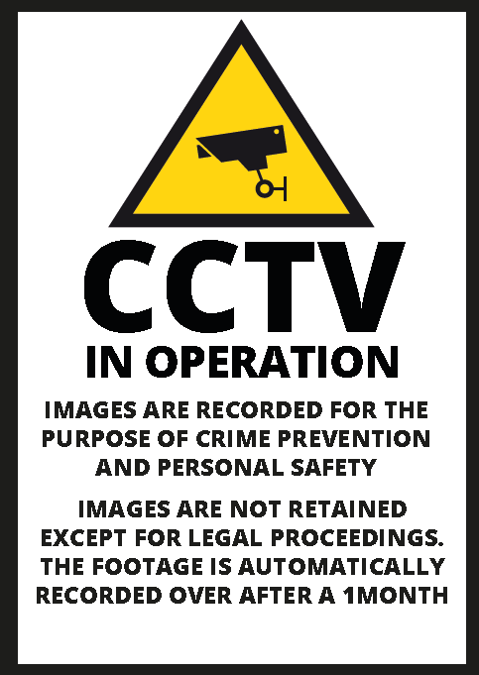



Cricketfield Surgery
Cricketfield Road
Newton Abbot
Devon
TQ12 2AS

01626 208020
cricketfield.admin@nhs.net

Leaflet V1.0 September 2019
Images
Access - Data Subject
Complaints

The Data Protection Act 2018 specifies the rights of access of the Data Subject.
All requests for access must be in writing on a Data Access form, which will be provided on request.
The Practice may charge a reasonable fee to provide the footage, depending on the demands of the request.
The form must be fully completed.
A response will be provided as soon as possible and in any event within 30 days. Where an application is declined, a reason will be given.
We only have access to footage recorded in the last month. We do not retain images unless pursuant to an investigation or legal proceedings.

Images are automatically recorded over after 1month.
All images will be held securely on a digital server, and all access requests and access to images will be documented.
Images may record individuals and / or record incidents. Not all recordings are designed to identify persons.
Other than in accordance with statutory rights, the release or availability of images will be at the discretion of the Practice Manager, or Operational Services Coordinator in their absence, who are Data Controllers for the purposes of the Data Protection Act.
Images are held to improve the personal security of patients and staff whilst on the premises, and for the prevention and detection of crime, and images may be provided to police or other bodies.
Where access is granted in response to an application received, the image may be edited to exclude images of third parties who may be also included within the requested image. This may be necessary to protect the identity of the third parties. In these circumstances the image released as part of the application may record / identify the “data subject” only.
Images will be located by a Data Controller or authorised person.
When assessing the content of the image released the decision will be taken by the Data Controllers having due regard to the requirements of the Data Protection Act and Code of Conduct.
Our full CCTV Policy with a Data Access Form attached is available on our website, or upon request.

These must be in writing and addressed to the Practice Manager.
Where the complaint is by a third party, and the complaint or enquiry related to someone else, the written consent of the Data Subject is required. Where this is not possible, full justification must be given.
All complaints will be acknowledged within 3 days.
Access - Third Party
Access by third parties will be tightly controlled to ensure the confidentiality of individuals. All requests will be in writing on the standard form provided,
The Practice may charge a reasonable fee to provide the footage, depending on the demands of the request.
Images will only be made available to third parties in limited and prescribed circumstances, and this will generally be restricted to law enforcement agencies.
Where an application is declined a reason will be given.
We only have access to footage recorded in the last month. We do not retain images unless pursuant to an investigation or legal proceedings.

Terms Used
Data Controller
This is the controller of the data and the system, as defined in the Act. In this case the Controllers for the Partnership are the Practice Manager and Operational Services Coordinator

Data Subject
This is the person whose image is within the system, and who has rights of access as determined under the Act.

Third Party
A person or body other than the Data Subject who requests access, or to whom an image may be provided.

Location of Cameras
There are 4 cameras installed on the premises.
1 exterior at the rear of the building, covering exit and carpark
1 viewing the front entrance
1 above the reception desk viewing reception area
1 at the top of the stairs viewing stairs and fire exit

